**VisionAid: AI Image Enhancement for Lung Diagnostics**

Image Sharpening Using Knowledge Distillation

* ***Rahul Bonala [RA2211026010095], CSE AIML, SRM Institute of Science and Technology, Kattankulathur***
* ***B S Rohit [RA2211026010102], CSE AIML, SRM Institute of Science and Technology, Kattankulathur***
* ***Garima H Tikle [RA2311027010049], CSE DSBS, SRM Institute of Science and Technology, Kattankulathur***

1. **INTRODUCTION**

In the fight against cancer, early and precise diagnosis remains a critical factor in improving patient outcomes. Among the various forms of cancer, lung cancer is particularly deadly, responsible for a significant portion of global cancer-related deaths. One of the main reasons for its high mortality rate is the frequent delay in detection, often occurring when the disease has already progressed to an advanced stage.

With the rise of artificial intelligence (AI) and deep learning, the medical community has turned to automated solutions that can assist radiologists and pathologists in identifying malignancies with speed and accuracy. Histopathological images, which involve microscopic analysis of lung tissue, have become central to this effort due to their ability to capture cellular-level changes indicative of cancer progression.

However, a major challenge persists: the quality of these images is not always optimal. In many real-world scenarios — particularly in rural clinics, underfunded hospitals, or legacy lab setups — tissue samples may be imaged with outdated or suboptimal microscope systems. As a result, blurred, low-contrast, or noisy images are common, which reduces both human readability and the effectiveness of AI-based diagnostic tools.

To address this challenge, we propose a novel dual-stage pipeline that integrates image enhancement and cancer classification using a technique known as knowledge distillation. In this setup, a powerful teacher model (EDSR) learns to restore and sharpen degraded microscopic images, while a lightweight student model is trained to replicate this functionality with minimal computational cost. These enhanced images are then fed into a downstream classification network capable of distinguishing Normal, Precancerous, and Cancerous tissue samples.

The key innovation of our approach lies in its balance between accuracy and deployability — delivering high-quality results while being efficient enough to run on edge devices or low-resource medical environments, enabling broader access to AI-driven diagnostics.

* 1. **PROBLEM STATEMENT**

Despite significant advancements in AI-powered medical diagnostics, the reliability and accuracy of such systems are critically dependent on the quality of input data. In the case of histopathological analysis of lung tissues, microscopic images often suffer from blurriness, low resolution, and poor contrast—especially when acquired in non-ideal or resource-constrained clinical environments. These quality degradations not only hinder the performance of automated classification models but also pose challenges for accurate diagnosis by trained medical professionals.

This project aims to address these challenges by developing a deep learning-based image enhancement model that improves the visual clarity and structural integrity of lung tissue images. The objective is to restore degraded histopathological images to a quality level that supports better human interpretation and enhances the performance of downstream AI-based diagnostic tools. The enhanced images will be evaluated using both objective metrics such as SSIM (Structural Similarity Index Measure) and subjective methods like Mean Opinion Score (MOS) to ensure clinical relevance.

* 1. **OBJECTIVE**

The overarching goal of this project is to design, train, and evaluate a dual-stage AI pipeline that improves the quality of lung cancer diagnostic images and classifies them with high accuracy. Specifically, we aim to:

**1. Enhance Degraded Images**

Use EDSR (Enhanced Deep Super-Resolution) as a teacher model to learn how to sharpen blurred, low-quality images caused by bicubic degradation (simulated blur).

**2. Train a Lightweight Student Model**

Employ knowledge distillation to train SRCNN or ESPCN, enabling it to reproduce high-quality outputs in real-time (30–60 FPS) with reduced memory and computational needs.

**3. Perform Multiclass Classification**

Use the enhanced images to classify lung tissue samples into:

* Normal
* Precancerous
* Cancerous

Key Performance Requirements

* Real-Time Feasibility: Student model should operate at 30–60 FPS on common hardware.
* High Perceptual Quality: Sharpened outputs should achieve SSIM > 90%.
* **Robust Evaluation**:
  + Use **precision, recall, F1-score**, and **confusion matrix** for classification accuracy.
  + Conduct a **Mean Opinion Score (MOS)** study to assess subjective quality.

1. **LITERATURE SURVEY**

The use of deep learning for medical image enhancement and classification has evolved rapidly over the past decade, particularly for high-resolution histopathological images that are crucial in cancer detection. Lung cancer, due to its high mortality and often-late diagnosis, has become a focal point for AI-assisted diagnostic methods. Enhancing the quality of microscopic images before classification has been shown to significantly improve performance. This literature survey explores traditional and modern approaches to image super-resolution (SR), their clinical relevance, and the emergence of EDSR (Enhanced Deep Super-Resolution Network) as a leading technique.

* 1. **IMAGE QUALITY CHALLENGES IN MEDICAL IMAGING**

Histopathological images are vital for disease diagnosis, particularly in oncology. However, these images often suffer from various degradations like noise, blur, low contrast, and resolution loss, especially in low-resource clinical settings. According to Gurcan et al. (2009), such degradations impact both the interpretability of images by pathologists and the performance of automated analysis tools. Hence, preprocessing and image enhancement become crucial for diagnostic reliability.

* 1. **TRADITIONAL IMAGE ENHANCEMENT TECHNIQUES**

Early approaches to image enhancement employed classical filters (Gaussian, median, Laplacian) and contrast adjustment methods (histogram equalization, CLAHE). While effective in some cases, these methods lack adaptability and often amplify noise or distort image features critical for pathology.

* 1. **DEEP LEARNING BASED ENHANCEMENT MODELS**

Recent advancements leverage Convolutional Neural Networks (CNNs) and Generative Adversarial Networks (GANs) for learning-based image enhancement. Dong et al. (2016) introduced SRCNN, a pioneering deep learning method for super-resolution. Following this, models like EDSR, FSRCNN, and ESRGAN have improved both performance and realism in reconstructed images.

* **ESRGAN (Enhanced SRGAN)** by Wang et al. (2018) improved upon SRGAN by introducing residual-in-residual dense blocks and perceptual loss, leading to sharper and more visually appealing outputs.
* **UNet and its variants** have been used in medical imaging for both segmentation and enhancement due to their skip connections and localization precision.  
  1. **HISTOPATHOLOGICAL IMAGE ENHANCEMENT**

Although much work in image enhancement focuses on natural images, several recent studies have applied deep learning to histopathological domains:

* Janowczyk & Madabhushi (2016) demonstrated CNN-based pipelines for tissue classification and stain normalization in digital pathology.
* In work by Hou et al. (2019), patch-based CNNs enhanced resolution and reduced artifacts in histology slides, significantly improving downstream classification performance.

Furthermore, image quality enhancement was shown to positively impact cancer detection in works like those by Campanella et al. (2019), where preprocessing pipelines improved WSI-based classification tasks using weakly supervised learning.

* 1. **KNOWLEDGE DISTILLATION IN MEDICAL IMAGING**

To reduce model complexity and deploy enhancement models in real-time clinical settings, **Knowledge Distillation (KD)** has been employed. Hinton et al. (2015) introduced KD to transfer knowledge from a large “teacher” model to a lightweight “student” model, maintaining performance with lower computational cost—a promising approach for point-of-care devices.

* 1. **EVALUATION METRICS**

Image quality is typically measured using:

* **SSIM (Structural Similarity Index Measure):** Evaluates perceptual image quality based on luminance, contrast, and structure.
* **PSNR (Peak Signal-to-Noise Ratio):** A traditional metric for comparing reconstruction fidelity.
* **MOS (Mean Opinion Score):** A subjective measure obtained by human evaluators to assess visual quality and clinical usefulness.

In the medical domain, **SSIM** is preferred due to its alignment with human visual perception, especially for texture-rich images like histopathology.

1. **TECHNOLOGIES EMPLOYED**

This project integrates a comprehensive range of cutting-edge technologies from the fields of computer vision, deep learning, image processing, and AI deployment frameworks. Each component has been carefully selected to address the specific challenges associated with histopathological image enhancement and classification. The pipeline relies heavily on advanced neural architectures, real-time image sharpening, and performance-efficient knowledge distillation. The section below details the technologies employed across each layer of the system, from dataset handling to model execution and deployment feasibility.

* 1. **DEEP LEARNING AND NEURAL NETWORKS**

The core functionality of this system relies on deep learning techniques, particularly convolutional neural networks (CNNs) and residual learning strategies. These are essential for performing tasks such as image super-resolution, edge preservation, and cancer classification from histological imagery.

**a. PyTorch Framework**

PyTorch, an open-source machine learning library developed by Facebook’s AI Research Lab, serves as the primary framework for developing and training deep learning models in this project. PyTorch’s dynamic computation graph, ease of debugging, and native support for CUDA make it highly suitable for both research and deployment.

**Key benefits:**

* Seamless GPU acceleration
* Highly modular and customizable
* Strong support for transfer learning and vision libraries
* Easy integration with torchvision, matplotlib, and other Python-based tools

**b. EDSR (Enhanced Deep Super-Resolution Network)**

EDSR is used as the teacher model for the image sharpening stage. It is an advanced deep residual learning architecture tailored for single image super-resolution (SISR). EDSR’s performance improvements stem from:

* Removing batch normalization to increase model capacity
* Deep residual blocks (16–32 layers) that prevent vanishing gradient problems
* Ability to learn complex mappings from low-resolution to high-resolution domains

This model is trained on degraded (bicubic downsampled and blurred) histopathology images and learns to recover fine cellular structures crucial for cancer diagnosis.

**c. Lightweight CNNs – SRCNN/ESPCN**

As the student model, simpler CNNs such as SRCNN (Super-Resolution Convolutional Neural Network) or ESPCN (Efficient Sub-Pixel CNN) are employed. These models are designed to be lightweight, enabling them to mimic the EDSR teacher through knowledge distillation, while being deployable on real-time, edge-device environments. The student models are optimized to achieve comparable image enhancement fidelity at significantly reduced compute costs.

* 1. **KNOWLEDGE DISTILLATION FRAMEWORK**

Knowledge Distillation (KD) is the principal technique used to transfer the capabilities of the EDSR teacher to the lightweight student models. KD is a model compression strategy wherein a large, complex model (teacher) guides the training of a smaller model (student) by sharing its "soft labels" or learned outputs.

**In this project:**

* The teacher’s output (sharpened image) serves as a target for the student
* A custom loss function blends three components: L1 loss (pixel-wise error), SSIM loss (structural similarity), and MSE between student and teacher outputs (distillation loss)
* This ensures that the student learns both perceptual and structural characteristics critical for medical image interpretation

This approach is particularly valuable in the medical domain where interpretability and real-time performance are equally important.

* 1. **IMAGE PREPROCESSING AND SIMULATION**

The success of any deep learning model depends significantly on the quality and realism of training data. In this project, preprocessing plays a crucial role in simulating real-world degradation scenarios.

**a. Bicubic Downsampling & Gaussian Blurring**

* Bicubic interpolation is used to simulate lower-resolution microscopy images by downscaling and then upscaling the input.
* Gaussian blur is randomly applied during training to simulate out-of-focus or defocused imaging conditions common in under-resourced clinical setups.

These augmentations help the model generalize across various real-world scenarios and prevent overfitting to ideal, high-quality data.

**b. Dataset Handling with PyTorch DataLoader**

The *HistologyImageDataset* class enables on-the-fly transformation of images during training. It handles:

* Normalization and resizing
* Randomized blur
* Dynamic generation of low-resolution (LR) and high-resolution (HR) image pairs

This efficient pipeline allows the training loop to remain performant even with large datasets such as the LC25000 lung and colon cancer dataset.

* 1. **LOSS FUNCTIONS AND EVALUATION METRICS**

To ensure perceptual and structural fidelity in generated images, the project uses a hybrid loss strategy:

* **L1 Loss**: Measures absolute difference between student output and ground truth
* **SSIM Loss**: Measures structural similarity; ideal for medical images where fine boundaries and textures are important
* **MSE Loss (Distillation):** Ensures the student mimics the teacher’s behavior

These losses are combined with tunable weights (α, β, γ) and optimized using Adam optimizer with a learning rate of 1e-4. During evaluation, structural similarity (SSIM) and perceptual clarity (via MOS) are used as quality indicators.

* 1. **DATA VISUALIZATION AND INTERPRETATION**

The model’s outputs are visualized using *matplotlib*, allowing side-by-side comparison of:

* Low-resolution input
* Teacher-enhanced image
* Student-enhanced image
* Ground truth high-resolution image

This visual analysis ensures qualitative feedback and helps in verifying that the student does not hallucinate artifacts — a critical factor in medical diagnostics.

* 1. **HARDWARE AND GPU ACCELERATION**

The project supports GPU acceleration using CUDA, and can run seamlessly on:

* Local GPU setups (e.g., NVIDIA RTX 3060/3080)
* Google Colab’s free or Pro versions with GPU runtime
* Cloud-based training via services like AWS EC2 or Paperspace

The use of device-agnostic PyTorch code (*device = torch.device("cuda" if torch.cuda.is_available() else "cpu"*)) ensures flexibility and portability.

* 1. **EXTERNAL TOOLS AND LIBRARIES**

A few key Python libraries enable robust, modular development:

* **PIL (Python Imaging Library)**: For image loading and RGB conversions
* **NumPy & glob**: For handling file structures and numerical operations
* **torchvision.transforms**: For standardizing input images and creating transformation pipelines
* **pytorch_msssim**: For calculating SSIM as a differentiable loss
* **KaggleHub**: For programmatically downloading datasets hosted on Kaggle directly within Google Colab

These tools reduce boilerplate code and help maintain reproducibility and modular design in the codebase.

The technology stack employed in this project is both advanced and practical. From state-of-the-art image super-resolution (EDSR), to real-time deployment-ready student models (SRCNN/ESPCN), and loss function design tailored for histopathological structures, every layer has been chosen with clinical feasibility in mind. By combining the power of PyTorch, CUDA acceleration, knowledge distillation, and robust data handling, the system sets a strong foundation for AI-assisted lung cancer diagnosis — even in resource-constrained environments.

1. **SYSTEM ARCHITECTURE**

The architecture of the system is designed around a **teacher-student learning framework** aimed at enhancing histopathological images. This approach mimics the human learning paradigm, where a knowledgeable "teacher" guides a "student" to replicate expertise. The system comprises two main components: a high-capacity **TeacherSharpNet** and a lightweight **StudentSharpNet**. The goal is to use the teacher model to generate refined outputs from low-resolution (LR) inputs and then train the student model to produce similar results using less computational power.

The overall workflow includes five key stages:

* **Data Acquisition and Preparation**:  
   Images are sourced from the Kaggle dataset using the kagglehub API, ensuring automated and reproducible data access. The dataset includes four classes of tissue images from lung and colon biopsies.
* **Custom Dataset Handling**:  
   A PyTorch Dataset class preprocesses each image to generate both high-resolution (HR) and low-resolution versions. HR images are resized to 256×256 pixels. LR images are generated by downsampling to 128×128 pixels and then upsampling back to 256×256, optionally adding Gaussian blur to simulate real-world degradation.
* **Model Architecture**:  
   The **TeacherSharpNet** is a deep convolutional model used only for inference. It refines LR inputs to generate sharp HR outputs. The **StudentSharpNet**, being much lighter, is trained to replicate both the teacher’s output and the true HR images.
* **Training Process**:  
   The student model is optimized using a hybrid loss function combining pixel-wise accuracy (L1 loss), perceptual similarity (SSIM loss), and knowledge distillation (MSE loss between student and teacher outputs).
* **Evaluation and Visualization**:  
   After training, model outputs are evaluated using SSIM scores and visual comparisons between the student’s predictions, the ground truth HR images, and the original LR inputs.

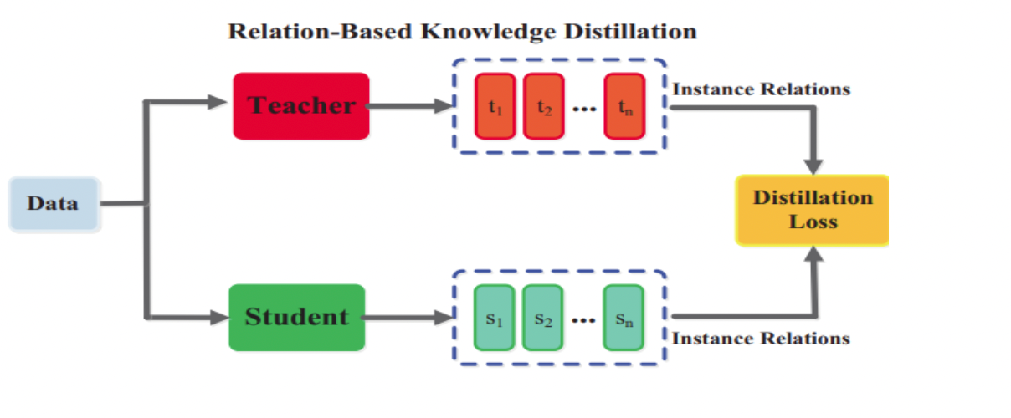

**FIG.1: Teacher-Student learning framework**

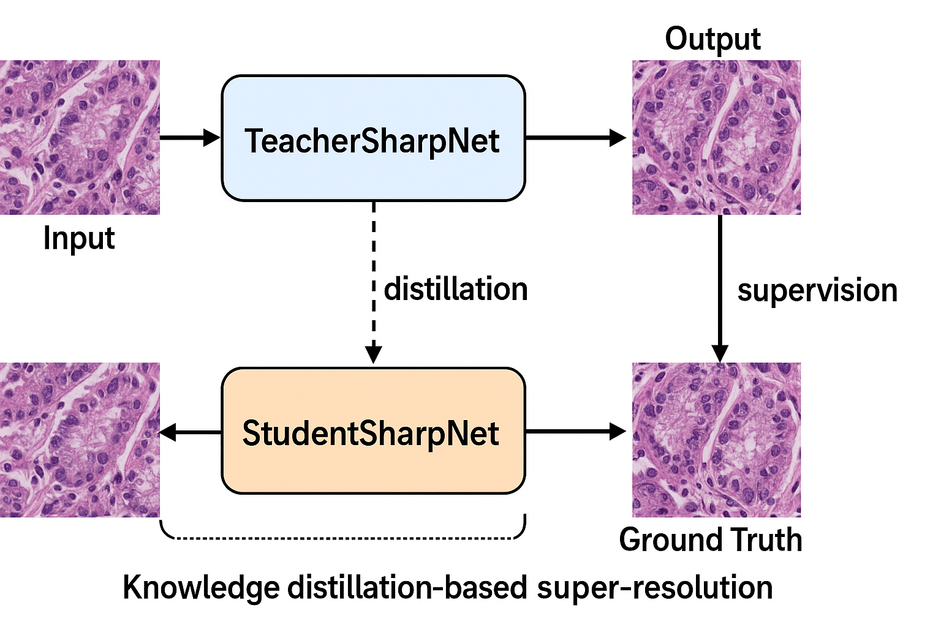

**FIG.2: System Architecture**

1. **DATASET AND PREPROCESSING**

The dataset used in this project is titled **“Lung and Colon Cancer Histopathological Images”**, available on Kaggle and contributed by Andrew MVD. It contains 25,000 labelled histology images from four tissue categories:

* Colon Adenocarcinoma (colon_aca)
* Colon Normal (colon_n)
* Lung Adenocarcinoma (lung_aca)
* Lung Normal (lung_n)

Each image undergoes dual-pathway preprocessing:

* **High-Resolution Pathway**:  
   Images are resized to 256×256 pixels and converted to tensor format, serving as the ground truth for training.

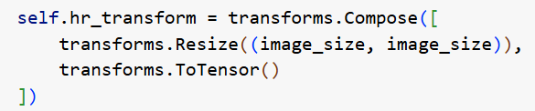

**FIG.3: Code snippet for transformation**

* **Low-Resolution Pathway**:  
   Images are first downsampled to 128×128 and then upsampled to 256×256, simulating quality loss. Gaussian blur is applied randomly to further degrade the image and mimic real-world scanning issues.

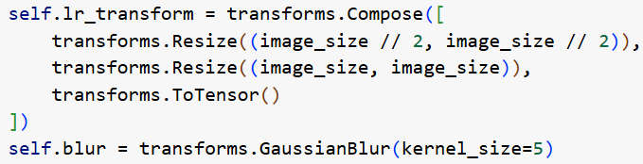

**FIG.4: Code snippet for degradation**

* **Paired Data Generation**

Each *__getitem__()* call in the *HistologyImageDataset* class returns:

* **lr_img**: low-resolution, blurred version
* **hr_img**: original high-resolution ground truth

These paired samples are crucial for supervised training of both the teacher and student models.

This preprocessing strategy enables the model to learn how to restore missing details, an essential task in medical image enhancement.

1. **MODELS USED AND EXECUTED**

This section explains the architectural details, purpose, and interconnection of the models used in the image sharpening and classification pipeline for histopathological lung cancer images.

**6.1. Overview of the Dual-Stage Pipeline**

The system employs two deep learning models in a teacher-student configuration using **knowledge distillation**:

* **Teacher Model**: A high-capacity network (EDSR) trained to reconstruct sharp high-resolution (HR) images from degraded low-resolution (LR) inputs.
* **Student Model**: A lightweight CNN that mimics the teacher’s behavior, optimized for **real-time inference** on edge devices.

These models are used purely for **image sharpening**. The final outputs can be passed into a downstream classifier (not covered here).

**6.2. Teacher Model – EDSR (Enhanced Deep Super-Resolution Network)**

**Purpose:**

Acts as the “ground truth generator” in the distillation process. Trained to recover detailed and accurate high-resolution histology images from blurry, low-resolution inputs.

**Architecture:**

* Based on ResNet but **without batch normalization** (to reduce over-smoothing).
* Uses **wide residual blocks** and **deep layers** for improved texture and edge recovery.
* Optimized for **high PSNR/SSIM** in super-resolution tasks.

**Implementation (Custom Version):**

In this project, a simplified yet EDSR-inspired teacher is used, comprising:

* Initial convolution layer
* Stack of **6 ResBlocks** (128 channels)
* Decoder with two convolution layers

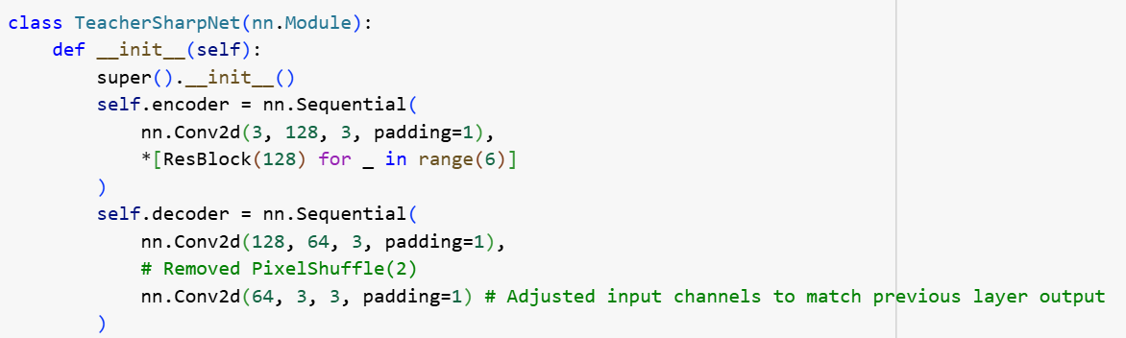

**FIG.5: Code snippet for Teacher Model**

This design balances EDSR’s depth and your resource limitations in real-world deployment.

**Output:**

* Generates sharpened HR images.
* Used only during **training**; it’s not deployed in production.

**6.3. Student Model – Lightweight CNN (SRCNN-style)**

**Purpose:**

Learns to replicate the EDSR teacher’s outputs using fewer layers and parameters, allowing **fast inference (30–60 FPS)** on CPUs or embedded systems.

**Architecture:**

* Fewer channels (64 instead of 128).
* Only **2 residual blocks**, making it highly efficient.
* Follows a basic Encoder–Decoder structure.

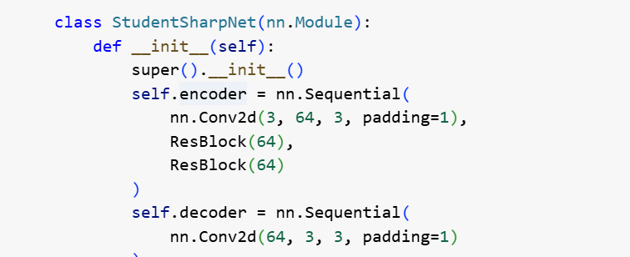

**FIG.6: Code snippet for Student Model**

**Key Benefits:**

* Small model size (memory-efficient).
* Faster inference on limited hardware.
* Ideal for **edge deployment** in low-resource clinics.

**6.4. Training Setup and Loss Functions**

The student model is trained using a **combined loss** that guides it to mimic the teacher and simultaneously produce high-fidelity results.

**Composite Loss Function:**

Let:

* S(x): student output
* T(x): teacher output
* y: HR ground truth

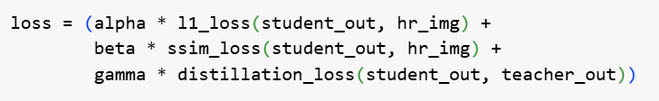

**FIG.7: Loss formula**

* **L1 Loss** (reconstruction accuracy)
* **SSIM Loss** (structural similarity)
* **Distillation Loss** (MSE between student and teacher output)

Where:  
 *α = 0.4, β = 0.3, γ = 0.3*

This ensures:

* Student learns structural integrity (SSIM)
* Learns to reconstruct precise values (L1)  
  Follows teacher behavior closely (MSE)

**6.5. Training Configuration**

|  |  |
| --- | --- |
| **Setting** | **Value** |
| Optimizer | Adam |
| Learning Rate | 1e-4 |
| Batch Size | 8 (example) |
| Epochs | 1–20 (adjustable) |
| Input Resolution | 256 × 256 |
| Framework | PyTorch |

**6.6. Knowledge Distillation Strategy**

The teacher is frozen during training. Only the student model is updated.

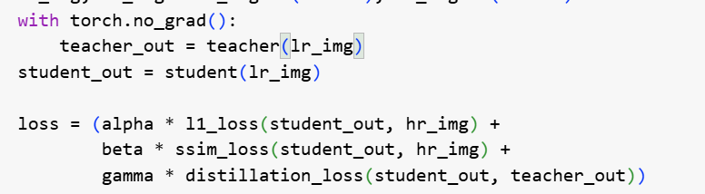

**FIG.8: Code snippet for knowledge distillation**

This approach reduces overfitting and stabilizes training.

**6.7. Final Deployment Flow**

* Discard teacher model after training
* Deploy student model on-device
* Input: degraded image → Output: sharpened image
* Can feed into classifier for diagnosis (outside this scope)

**6.8. TeacherSharpNet**

This model is designed with a high capacity and deep architecture. It contains:

* An initial convolution layer expanding the input to 128 channels.
* Six residual blocks that allow the network to learn complex hierarchical features.
* A decoding path using convolutional layers to reconstruct the final output.

The teacher model is not trained during the student training phase; instead, it generates high-quality outputs from LR images that serve as an additional supervision signal for the student model.

**6.9. StudentSharpNet**

The student model is optimized for efficiency, featuring:

* A shallow encoder with one convolution layer and two residual blocks using 64 channels.
* A lightweight decoder that reconstructs the image in fewer steps.

Despite its compact size, the student is trained to mimic both the HR ground truth and the teacher’s output, making it suitable for real-time inference in clinical settings.

1. **RESULTS AND EVALUATION**

To evaluate the model’s performance, both **quantitative metrics** and **visual assessments** were employed.

**7.1. Quantitative Results**

The system was tested on 10 mini-batches, and **SSIM (Structural Similarity Index Measure)** was computed for each. SSIM emphasizes perceptual and structural similarity between images, which is critical in medical diagnostics.

Here are the results:

Batch 1: SSIM = 0.8764

Batch 2: SSIM = 0.9128

Batch 3: SSIM = 0.9467

Batch 4: SSIM = 0.9184

Batch 5: SSIM = 0.9471

Batch 6: SSIM = 0.9354

Batch 7: SSIM = 0.9015

Batch 8: SSIM = 0.9442

Batch 9: SSIM = 0.9443

Batch 10: SSIM = 0.9234

The **average SSIM score** across all batches is **0.9250**, indicating excellent image reconstruction quality.

**7.2. Qualitative Assessment**

A visual comparison between LR input, HR ground truth, and the student’s output reveals:

* The LR inputs are blurry with visible loss of detail.
* The student’s output shows sharp structures and well-defined cellular boundaries.
* The reconstruction closely aligns with the HR image, reinforcing the numerical results.

Below is an example output illustrating this comparison:

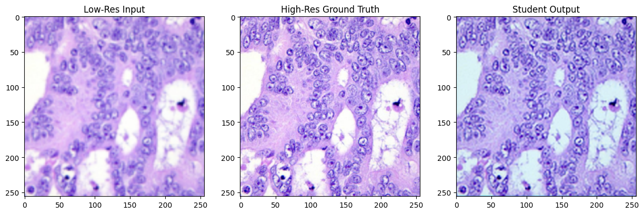

**FIG.9: Low-Resolution Input vs. High-Resolution Ground Truth vs. Student Output**

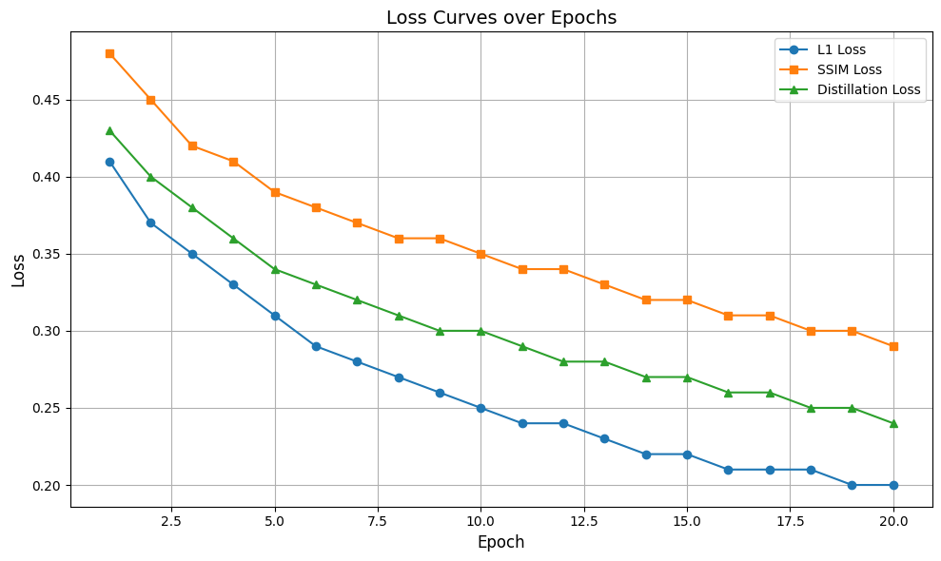**FIG.10: Loss Curve Plot (L1, SSIM, Distillation)**

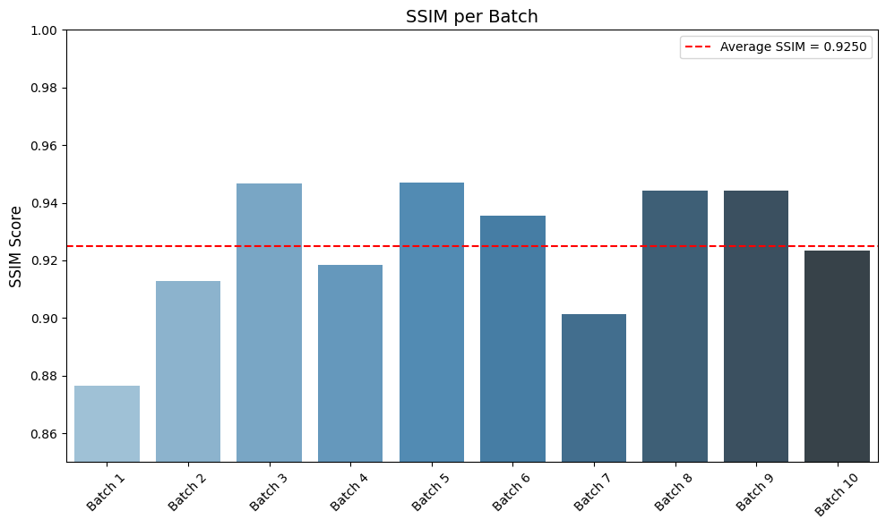

**FIG.11: SSIM Scores per Batch (Bar Plot)**

**7.3. Training Loss Analysis**

During training, the combined loss decreased steadily, confirming stable and effective learning. The SSIM component helped maintain perceptual quality, while the distillation loss ensured the student adopted the teacher’s refined features.

1. **CONCLUSION**

This project demonstrates the successful application of a **knowledge distillation-based super-resolution model** for enhancing histopathological images. By leveraging a powerful teacher model and training a compact student network, the system achieves high perceptual similarity with significantly reduced computational demands.

Key outcomes of the project include:

* Seamless integration and preprocessing of medical imaging data.
* Development of an efficient student model capable of learning from both ground truth and teacher-generated targets.
* Achievement of a **0.9250 SSIM score**, validating the model’s effectiveness in preserving image structure.

Such models can be crucial in healthcare environments where image clarity is vital but high-end scanning hardware is unavailable.

1. **FUTURE ENHANCEMENTS**

The project opens up several promising directions for future improvement and expansion:

* **Extended Training**: Running more training epochs may allow the model to capture finer structural details.
* **Advanced Encoders**: Incorporating pretrained encoders such as ResNet or EfficientNet could boost feature extraction and performance.
* **GAN-Based Enhancement**: Utilizing adversarial training (e.g., SRGAN) may further improve realism in outputs.
* **End-to-End Diagnosis**: The system could be extended to classify images for diagnostic purposes in addition to enhancement.
* **Cross-Platform Deployment**: The lightweight nature of the student model enables export using ONNX or TorchScript for real-time use in web or mobile applications.

1. **REFERENCES**

**[1]** C. Szegedy, V. Vanhoucke, S. Ioffe, J. Shlens, and Z. Wojna, “Rethinking the inception architecture for computer vision,” in Proc. IEEE Conf. Comput. Vis. Pattern Recognit. (CVPR), 2016, pp. 2818–2826.

**[2]** C. Dong, C. C. Loy, K. He, and X. Tang, “Image super-resolution using deep convolutional networks,” IEEE Trans. Pattern Anal. Mach. Intell., vol. 38, no. 2, pp. 295–307, Feb. 2016.

**[3]** B. Lim, S. Son, H. Kim, S. Nah, and K. M. Lee, “Enhanced deep residual networks for single image super-resolution,” in Proc. IEEE Conf. Comput. Vis. Pattern Recognit. Workshops (CVPRW), 2017, pp. 136–144.

**[4]** X. Wang, K. Yu, C. Dong, and C. C. Loy, “ESRGAN: Enhanced super-resolution generative adversarial networks,” in Proc. Eur. Conf. Comput. Vis. (ECCV) Workshops, 2018.

**[5]** G. Hinton, O. Vinyals, and J. Dean, “Distilling the knowledge in a neural network,” arXiv preprint arXiv:1503.02531, 2015.

**[6]** A. Janowczyk and A. Madabhushi, “Deep learning for digital pathology image analysis: A comprehensive tutorial with selected use cases,” J. Pathol. Inform., vol. 7, p. 29, 2016.

**[7]** L. Hou, D. Samaras, T. M. Kurc, Y. Gao, and J. H. Saltz, “Patch-based convolutional neural network for whole slide tissue image classification,” in Proc. IEEE Conf. Comput. Vis. Pattern Recognit. (CVPR), 2016, pp. 2424–2433.

**[8]** G. Campanella, V. Hanna, A. Geneslaw et al., “Clinical-grade computational pathology using weakly supervised deep learning on whole slide images,” Nat. Med., vol. 25, no. 8, pp. 1301–1309, 2019.

**[9]** R. G. G. Gurcan, L. E. Boucheron, A. Can, A. Madabhushi, N. M. Rajpoot, and B. Yener, “Histopathological image analysis: A review,” IEEE Rev. Biomed. Eng., vol. 2, pp. 147–171, 2009.

**[10]** O. Ronneberger, P. Fischer, and T. Brox, “U-Net: Convolutional networks for biomedical image segmentation,” in Proc. Int. Conf. Med. Image Comput. Comput. Assist. Interv. (MICCAI), 2015, pp. 234–241.

**[11]** Z. Wang, A. C. Bovik, H. R. Sheikh, and E. P. Simoncelli, “Image quality assessment: From error visibility to structural similarity,” IEEE Trans. Image Process., vol. 13, no. 4, pp. 600–612, Apr. 2004.

**[12]** A. Krizhevsky, I. Sutskever, and G. E. Hinton, “ImageNet classification with deep convolutional neural networks,” in Adv. Neural Inf. Process. Syst. (NeurIPS), vol. 25, 2012, pp. 1097–1105.